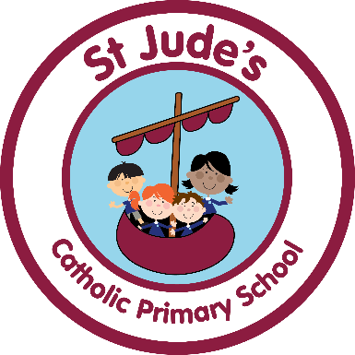

This year we took part in the

‘Big Lent Walk’

to raise vital funds for communities around the

world and to fight global poverty. We put on our walking shoes and walked every day in school during Lent. Our school community sponsored us in helping to make a difference!

We began our daily walk on 27th February and we walked daily until 31st March.

We raised a total of £318.10.

These are the World Gifts we have chosen to buy and why:

2 Healthy mum and baby packs £40 each

10 Trees for life £8 each

2 Period packs £10 each

3 Veggie Gardens £5 each

5 Packs of worms £10 each

1 Goat that Gives £28 each

1 Water Supply for a family £33 each

2 Keep Clean packs £6 each

We discussed the impact these World Gifts would have and this is what we said,

“Goats give milk and important vitamins to a family and even when the goat dies they can eat the meat”.

“Families in Bangladesh really need clean water. We had an assembly about this.”