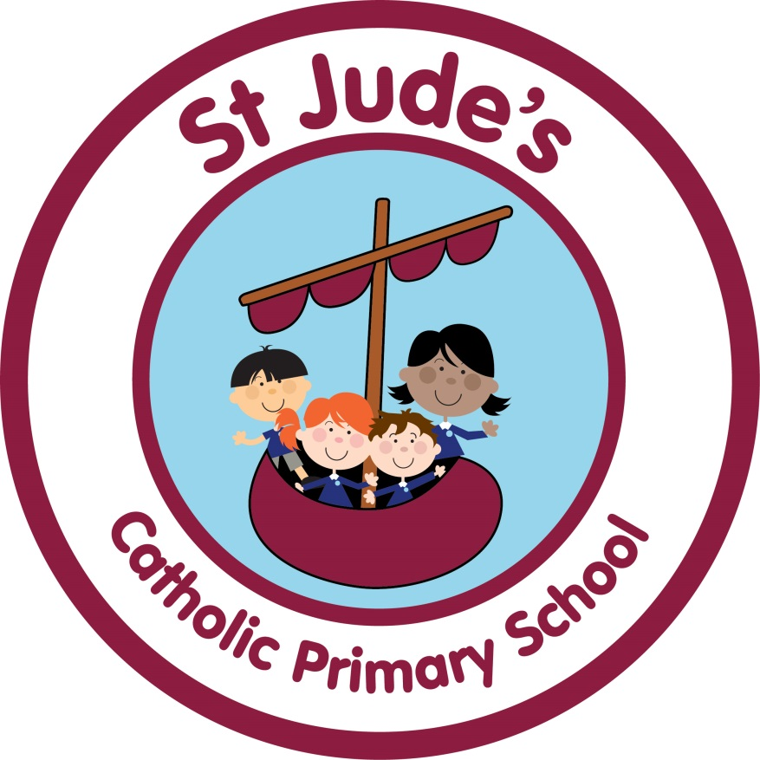

**RELIGIOUS EDUCATION HANDBOOK**

Together, we learn, love and grow with Jesus

Written by: R. Jackson Autumn 2022

Governors approved: Autumn 2022

To be reviewed: Autumn 2024

|  |  |
| --- | --- |
| **LEADER / CO-ORDINATORS** | Mrs R Jackson |
| |  |  | | --- | --- | |  |  | | **GROUPS INVOLVED IN DISCUSSION** | | | |  | | --- | | Headteacher  Senior Leadership Team  All Staff  Governing Body  Children  Parents | |

This policy provides a framework for all staff which includes guidance on planning, assessment, recording and reporting in Religious Education. It offers guidance on teaching styles and opportunities for meeting the needs of all pupils, as well as giving advice on equality.

**Religious Education is the core subject which is central to the life of our school.**

**MISSION STATEMENT**

As stated in our school’s Mission Statement, our 3 aims are to –

To nurture and inspire each individual so that they can learn and grow in order to reach their full potential

To be a Christian family bringing the Gospel to life by word and example (action/deed)

To develop, maintain and strengthen relationships between school, church, home and wider community.

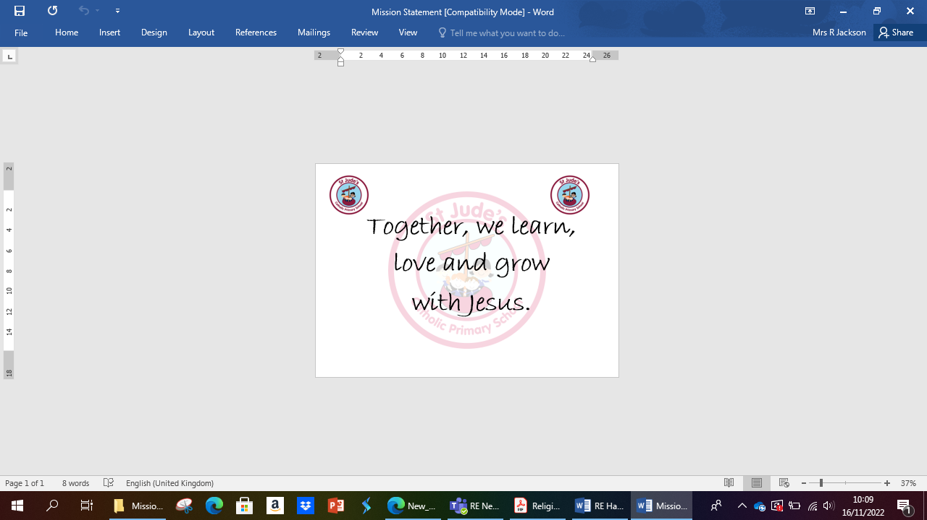

The staff of St. Jude's Catholic Primary School will work to give each child the entitlement of a broad, balanced, differentiated curriculum (irrespective of ability) encouraging in every individual a sense of self-worth and self-esteem. All teaching and learning is underpinned by the school mission statement.

**THE AIMS AND OBJECTIVES OF RELIGIOUS EDUCATION AT ST. JUDE’S ARE:**

In the words of the Curriculum Directory 2012, -

*‘****The outcome of excellent religious education is religiously literate and engaged young people who have the knowledge, understanding and skills – appropriate to their age and capacity – to reflect spiritually, and think ethically and theologically, and who are aware of the demands of religious commitment in everyday life.’***

We ensure that our Mission Statement reinforces this message.

Using ‘Come and See’ we provide the comprehensive and systematic study of:

* the mystery of God;
* the life and teachings of Jesus Christ;
* the teachings of the church;
* the central beliefs that Catholics hold and the basis for them;
* the relationship between faith and life.

These are explored in a manner, which encourages investigation, and reflection by the pupils, develops the appropriate skills and attitudes and promotes free, informed and full response to God’s call in everyday life.

To achieve these aims we will:

* Present comprehensive content which is the basis of knowledge and understanding of the Catholic faith
* Enable pupils continually to deepen their religious and theological understanding and to be able to communicate this effectively
* Present an authentic vision of the Church’s moral and social teaching so that pupils can make a critique of the underlying trends in contemporary culture and society.
* Raise pupils’ awareness of the faith and traditions of other religious communities in order to respect and understand them.
* Develop the critical faculties of pupils so that they can relate their Catholic faith to everyday life
* Offer children a sense of self-worth through their experience of belonging to a caring community and an awareness of the demands of religious commitment in everyday life
* Enable pupils to relate the knowledge gained through Religious Education to their understanding of other subjects in the curriculum
* Enable pupils to engage with their own and others’ beliefs and values to help develop good attitudes and dispositions so that the children are instilled with a love of learning and a desire to go on learning
* Enable pupils to engage with difficult questions of meaning and purpose which everyone has to face to enable them to think critically about their own questions of meaning and purpose

(As advised by the Religious Education Curriculum Directory for Catholic Schools 2012 & Come and See)

**THE RELIGIOUS EDUCATION PROGRAMME**

To fulfil our aims and objectives we use the *‘Come and See’* programme of Religious Education recommended by the Archdiocese of Liverpool.

The following pages show an overview of the Themes and Topics over the year cycle of Come and See.

**The Process**

Come and See is developed through three themes based on the above documents of the Second Vatican Council, which are gradually explored each time at greater depths. They are **Church, Sacrament and Christian Living.** The process for delivering each of the topics in Come and See has three main stages, which enable pupils to develop knowledge, skills and attitudes.

**Explore**

**Reveal**

**Respond**

The process encompasses a variety of teaching and learning styles, which enables the needs of individual pupils to be met.

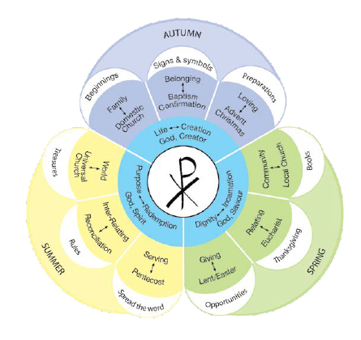

**THE APPROACH CHOSEN**

We have chosen a whole school approach to the long term planning for Religious Education so that all pupils explore their topics at the same time, following a one-year cycle.

In the foundation stage Religious Education drives the whole curriculum. Throughout the programme Nursery and Reception will follow this process:

Whole class core input - Adult directed group activities – Continuous provision.

From Year 1 to Year 6 the structure within Explore and Reveal lessons will be as follows:

Learning focus – content – key questions – suggested activities.

The Respond lessons will give the children the opportunity to respond and remember what they know, the structure will be as follows:

Remember – Rejoice – Renew

**TIME ALLOCATION FOR RELIGIOUS EDUCATION**

The Bishop’s requirement of 10 percent of curriculum teaching time is clearly indicated on the class timetables. This time does not include time for Collective Worship/Prayer and Liturgy.

In Key Stage One and the Foundation Stage the time spent on RE each week is at least 2 hours and 10 minutes. In Key Stage Two the time spent on RE each week is at least 2 hours and 30 minutes. The SLT are responsible for ensuring that this takes place.

Theological foundations

**PLANNING**

Long-term planning –

Long term Planning is the responsibility of the Leadership Team. Each class and subject has its own long term plan according to the programme of study. In Religious Education the themes and topics framework sets out the programme for the year. Teachers are responsible for becoming familiar with each theme so that they know how the year will develop and how each theme and topic can be linked with each other and other areas of the curriculum.

We also have a long term plan which links RE with our RSE Programme, A Journey in Love, so that teachers know when links can be made appropriately.

Medium-term planning –

The Medium Term planning is the responsibility of the RE subject leader who ensures that each teacher has the relevant planning sheet for each term’s work. This highlights:

* the content and focus of each theme
* links to the Catechism of the Catholic Church and Religious Education Curriculum Directory
* Key concepts, skills and attitudes
* Attainment targets
* Christian doctrine for the term
* The three themes and topics
* The start dates for each topic (each topic should be given equal time – each topic will take four weeks to complete)

The planner shows the allocated length of time required to ensure that the three learning outcomes for each topic will be achieved.

Delivery of a topic requires approximately ten hours. It is recommended that the following structure is followed:

* Explore A quarter of the time allocation
* Reveal Half of the time allocation
* Respond A quarter of the time allocation

Prior to each theme the RE coordinator will share *‘Come and See for Yourself’* with all the staff during our staff briefing. This allows the staff to gain an understanding of the topic and to reflect on the topic personally and how it relates to their life and personal experiences, before sharing it with the children.

Short term planning

Short Term Planning is the responsibility of the class teacher. Planning is documented on the recommended planning proforma from the Archdiocese which has been adapted by the RE Coordinator. At St. Jude’s, teachers also create ‘PowerPoints’ which are used with the children and should include the following-

* Key words for the topic
* Objectives and Success Criteria for every lesson
* Standards-Skills (previously known as ‘driver’ words)
* Key stages of process
* Differentiation and activities
* Resources
* Reflection
* Evaluation

Teachers should plan the whole topic to allocate sufficient time to ensure achievement of the three learning outcomes. Within all classes, teachers consider the attainment levels when developing activities for children of different abilities.

Appropriate activities should be planned to ensure the achievement of the learning focuses and overall learning. Lessons should be evaluated. Groupings should be indicated to show how the differing needs and abilities of children are to be met and standards-skills should be used to set learning objectives. Time should be set aside for formal assessments and teachers should indicate on planning the activities which were chosen for the formal assessments.

Differentiation

In St Jude’s Religion work is set against the Religious Education standards skills. Children are given the same tasks but supported through resources. All children are given the same opportunity to achieve their best.

Additional learning needs and/or disabilities –

In St Jude’s teachers take into account all children with a variety of additional learning needs andplan accordingly. Come and See aims to provide meaningful and appropriate religious education experiences for all children, taking account of different needs, abilities and learning styles.

Teachers also refer to the ‘SEN’ (Special Needs folder) link on the Come and See website for tried, tested and suggested activities for children working within P levels with cross- referencing into the programme’s themes.

**ASSESSMENT**

Assessment is focused by the overall aims and objectives of Religious Education ‘*Come and See’* and the Religious Education Curriculum Directory for Catholic Schools and Colleges.

In *‘Come and See’*, it is related to the concepts, skills and attitudes to be developed through the exploration of the themes and the learning outcomes for each topic. Assessment establishes what pupils know, understand and can do. It does not assess faith or the practice of faith. Assessment in *‘Come and See’* emphasises a wide range of achievement.

At the beginning of *Explore and Reveal* there is an indication of the Areas of Learning and the Attainment Levels which are covered. At the end there is a summary of the levels for that topic. As a staff, we consider assessment to be an integral part of teaching and learning. We recognise the unique contribution of every pupil to Religious Education and the whole range of skills, aptitudes and capabilities that every pupil may exhibit. At St. Jude’s assessment involves formal and informal assessment.

Informal assessment

Informal assessment is on-going and can take the form of a quiz, pictures, diagrams, roleplay, questioning or any other format a teacher feels would help their summative assessment. Tracking for each child is updated every term to ensure progress is monitored. Informal assessment should include:

* General observation of children engaged in general tasks and activities
* Observation of contributions made to classroom displays
* Review: end of task, activity, lesson, topic
* Marking of more formal written work

Formal assessment

Assessment follows the guidelines provided by the Archdiocesan Education Team. The themes to be assessed have been selected for teachers covering a three year cycle, each year covering three themes, and indicate the Attainment Target focus. One topic per term is identified by the Christian Education Team for formal assessment.

* Each term, every child must be assessed formally, as indicated on the assessment cycle sheet.
* Assessment tasks are on the Archdiocesan website but will also be distributed by the coordinator.
* A staff moderation meeting is to be held annually to agree levels as well as cluster moderation meetings to verify these.
* Each teacher is to keep 3 samples of work from each formally assessed topic. (HA, AA, LA) Copies should be given to Co-ordinator to put into the school portfolio.
* The Record of Attainment should be completed at the end of each term. Together with information gained from discussions, observations, class work and assessments etc. Should be used to find a ‘best fit’ level for the child.
* Marking of work should be positive, encouraging and developmental. Comment on progress towards leaning outcome.
* Reception class will develop a portfolio of annotated work from each topic including photographic evidence.
* The Record of Attainment will go with the child’s other records to secondary school to celebrate where the child is at in their learning and to enable further progress from the appropriate starting point

Attainment Targets and Levels of Attainment

In each classroom a record of attainment for each child is kept in their assessment folder, along with their assessed work. This is updated regularly and then passed on to the next class teacher.

**RECORDING**

At St Jude’s, recording takes many forms;

* Notes from observations
* Written comments on children’s work
* Visual evidence – displays, celebrations etc.
* Photographs and roleplay – video evidence
* Year group assessment and evidence files
* Portfolios containing a selection of work and teachers’ comments.

**REPORTING**

At St Jude’s reporting provides feedback to pupils on their achievements and progress, informs teacher colleagues of the achievement of individual pupils and the areas studied by the class and year group, informs parents of the progress and achievement of their children and informs parents, governors, parish and external agencies of the content and quality of Religious Education being provided and achievement of the pupils.

At the end of each school year teachers pass on assessment folders to the next class teacher and Religion books are kept to allow teachers to communicate with each other and to pass on levels of attainment and general feedback for each pupil. These assessment folders should also be used as the basis for reporting to parents at the end of the year.

Two parents’ evenings are held each year when each child’s progress is reported and written reports are delivered at the end of each academic year. As well as this, parents are very welcome to enquire about the progress and achievements of their children.

‘Assessment is an integral aspect of all teaching and learning.’

*(The Independent Review of the Primary Curriculum 2009: 1.22)*

**EVALUATION OF TEACHING**

In order to review, monitor and evaluate the teaching of ‘Come and See’ in St. Jude’s the RE lead monitors Religion plans and books and carries out pupil voice on a termly basis. Lesson drop-ins also take place on a termly basis and in order to share good practice the RE lead will share individual feedback to each teacher and general feedback at a staff meeting. Teachers’ plans and formal assessments are kept in a monitoring folder. Teachers evaluate each lesson which will inform future teaching and learning and include assessment for learning.

Prayer and Liturgy monitoring takes place each term and in order to share good practice the RE lead visits each class with the neighbouring teacher to do this. Again individual and general feedback is provided.

Displays, focus tables and resources will also be monitored via a learning walk. In the classroom, display boards highlight the work carried out by each year group in the same ‘Come and See’ topic. This illustrates progression and the different learning and teaching styles employed by the individual class teachers for the same topic. It also gives the opportunity for children to see what work is going on in other year groups and to appreciate each other’s work.

**EVALUATION OF LEARNING**

At St. Jude’s we aim to enable the children to evaluate their own learning through the ‘Respond’ section in ‘Come and See’, at the end of each topic.

Remember

The children will respond by remembering and celebrating all that they have learnt.

This may be done through:

* creating a quiet, prayerful atmosphere for reflection
* looking at and thinking about the work done
* drawing attention to different aspects of this work
* sharing thoughts and feelings

Renew

The teacher helps each child to make an individual response, to hold on to and make their own, what they have understood of the topic. In this part the children will think about how they can apply their learning to their lives. Older children can be offered the opportunity to write or draw in their Religion books or in their personal notebook. Children are given the opportunity to complete a task in school and then take it home to share.

The RESPOND section of each topic will take one week of Religious Education time to complete.

**STAFF DEVELOPMENT**

At St. Jude’s, training and development takes place throughout all aspects of school life and takes into account all members of our school community. The needs of individuals, teams and the whole school are given consideration when identifying areas for development. Objectives for training and development are closely linked to the School Improvement Plan. The impact of Training and Development on practice is evaluated so that our school can sustain and improve its performance.

All staff are informed of the Archdiocesan CCRS programme and are encouraged to attend if they do not have this qualification. When staff are recruited we actively look for the qualification: Catholic Teacher’s Certificate, or a willingness to complete the qualification. New staff without the qualification are supported through our induction procedures and encouraged to work through the appropriate training provided by LACE.

The RE subject leader attends all RE lead courses and training to keep and maintain up to date standards of good practice and latest adjustments or changes which will affect the school. This is then reported on to other colleagues within the school. The RE lead also attends the Wigan cluster group meetings.

Come and See for Yourself

Prior to each new topic from the ‘Come and See’ programme the RE lead leads Come and See for Yourself. A focus table is set up and staff are invited to share and reflect on the upcoming topic. During our staff briefing this resource is used to give staff the opportunity for reflection, sharing and discussion. All staff are invited to share this.

Further guidance for teachers can be found in the Come and See programmes for each year group at the beginning of each topic.

Staff communication

At St Jude’s communication and consultation with staff are carried out on both a formal and informal basis. Staff are informed by the RE lead which topics are to be covered each academic year and the dates each topic starts within the term, by means of the medium term planning sheet. Key Stage and Whole School Prayer and Liturgy is planned for and timetables are distributed at the beginning of every half term.

Staff also have a timetable outlining key dates for Class Collective Worships/Prayer and Liturgies, which are led by the children and attended by parents.

An information sheet regarding RE events is distributed at the beginning of each academic year and these are included on the weekly diary. Parents receive a termly Come and See newsletter which includes the key dates for school.

Staff meetings are planned termly and dedicated to moderation of formal RE assessment. Other relevant staff CPD takes place based on audits and monitoring throughout the year.

**RESOURCES**

Staff members

All members of staff teach R.E. and take assemblies and lead collective worship.

Pre-school – Miss Lauren Penworth

Reception – Mrs Jenny Wilkinson (CCRS – in progress)

Year 1 – Mrs Alice Crosbie (CCRS) and Mrs Rachel Cregan (CCRS)

Year 2 – Mrs Dorne Stevens (CCRS – in progress)

Year 3 – Miss Jessica Dooney

Year 4 – Miss Jessica Unsworth CCRS)

Year 5 – Miss Kirsty Hulme (CCRS)

Year 6 – Mr Ian Parry (CCRS – beginning September 2023)

DHT and RE lead – Mrs Roisin Jackson (equivalent of CCRS)

HT – Mr Damian Wilson (CCRS – in progress)

Resources

At St Jude’s R.E. has an equal place alongside other subjects, enriching them to create greater value and coherence. The Re lead is responsible for the maintenance of RE resources.

There are a wide range of artefacts and resources stored in the R.E. cupboard which is allocated in the corridor between the Year 5 and the Year 6 classrooms.

Each **classroom** has:

*Collective Worship box* – candles, floating candles, beads, pebbles, shells, pine cones, Bible, various cloths, bubbles, picture frame, crucifix, bowl, heart artefact

*Resources for focus table* *and lessons* – Come and See Book, God’s Story 1, 2 & 3, Church’s Story 1, 2 & 3 (both of which are available on IWB), crucifix, candles, teacher make use of the CAFOD website as well as other appropriate websites, Bibles (if needed teachers use the RE resource cupboard to source resources for their classroom e.g. love statues). Resources are updated on a termly basis as and when needed.

Religious Education resource cupboard:

*Church artefacts* – chalice,

*Variety of candles* – Advent Wreath candles, varied sizes of Church candles, floating candles, candle holders, tealights

*Collective Worship resources* - pebbles, pine cones, decorative leaves / butterflies,

*A range of cloths –* coloured cloth for each part of the Liturgical year, cloth for altar for school masses

Christmas – Posada for each class, crib for each class,

Other faith resources including Judaism, Islam and Hinduism.

Training

Please refer to our CSED for training attended and booked for the upcoming year.

**RELATIONSHIP OF R.E. TO THE WHOLE CURRICULUM**

Collective Worship/Prayer and Liturgy

At St Jude’s Collective Worship takes place each day. There are opportunities to worship as a whole school, in separate Key Stages and as a class family. There are also opportunities each term for class and whole school assemblies and celebrations to which all pupils, parents and parishioners are welcome. (see Collective Worship/Prayer and Liturgy Policy)

Spiritual and Moral Development

At St Jude’s the spiritual and moral development of our children is of fundamental importance. A variety of opportunities are provided for children and staff to reflect upon their place in the universe and their role in living according to the teachings of Jesus (see Spiritual and Moral policy)

Away Days and Retreats

Year 6 are given the opportunity to participate in a ‘Spiritual Retreat’ with Animate as part of their transition.

Links with Parents

We strive to have close links with parents at St Jude’s, in the form of Home/School initiatives, an open door policy and a positive attitude towards parental help in school. Through sacramental programmes, pre-school meetings, parent’s evenings and school celebrations we involve parents in their child’s religious education and, indeed, their education as a whole. Whilst in school parents are invited to share their thoughts and reflections as their children celebrate and share the liturgy.

Links with Parish

At St Jude’s we have created and fostered relationships with the parish of St Jude’s in several ways. There are open invitations to school assemblies, celebrations, choir concerts, Carol Services and Christmas Nativities. We work together in sacramental preparation and we support parish functions, such as the Christmas and Summer Fayres and harvest. We also welcome two parishnors who come into school on a weekly basis to say the Rosary with our KS2 children, alongside our priest.

**SACRAMENTAL PREPARATION**

St. Jude’s Catholic Primary School fully supports the parish in their preparation of the children for the Sacraments of Confirmation, Eucharist and Reconciliation. Parents are invited to an initial meeting during which the process of preparation and the commitment required is outlined. Input from the parish priest, school and catechists is given.

We follow the ‘With You Always’ Programme. This is a resource for parents and their children who are in Year 4. The resource encourages parents/carers and children to meet together with parish catechists, supported by the school, to learn about the sacraments using the family catechesis method. Parents are the first and best teachers of their children in the ways of faith as is made clear when the child is baptised. The goal of family catechesis is the evangelisation of the whole family with particular emphasis on the support of parents to pass on the faith to their children. Family catechesis helps support the Home-Parish-School partnership.

In order to achieve the aims outlined above, the children will have the opportunities in Religious Education to:

* Develop confidence, value and pleasure in Religious Education;
* Work both independently and with others, listening to others' ideas and treating these with respect;
* Be creative, flexible and show perseverance;
* Record responses, including observations of the natural and man-made environment;
* Develop a respect for the environment and for their own health and safety and that of others;
* Develop their cultural awareness and understanding and appreciate the value of differences and similarities;
* Develop an understanding that all people are equal regardless of age, race, gender or ability and that there needs to be alternative solutions to meet the needs of individuals and groups of people;
* Find enjoyment, satisfaction and purpose through Religious Education;
* Express their own ideas, feelings, thoughts and experiences through Religious Education.

Relationships and Sex Education

At St Jude’s we value the importance of personal relationships and the need to nurture such qualities as tolerance, respect for persons and property, compassion, co-operativeness, sensitivity, honesty and love in our children. This is part of everyday life at St Jude’s and is fundamental to our Mission Statement and an integral part of our school. At St Jude’s education for personal relationships is integrated within the curriculum and is taught through a variety of subjects including R.E., PSHE and RSE. Our RSE programme is ‘A Journey in Love’ and ‘The PSHE Association’ is used for our PSHE curriculum.

The RE lead and the PSHE lead worked together to map out a long term plan so that links could be made between RE, RSE and PSHE. Teachers use these to plan.

Inter-Relationships between R.E and other Policies at StJude’s

Religious Education at St Jude’s ensures our children have provision for Spiritual and Moral Development, Collective Worship, RSHE, Special Educational Needs, ICT, Anti-bullying, Marking and Feedback and PSHE.

For further information see relevant policies.

**THE ROLE OF THE GOVERNORS**

Our RE link governors, with the support of the governing board determine, support, monitor and review the school’s approach to teaching and learning. In particular, they:

* Support the use of appropriate teaching strategies by allocating resources effectively;
* Ensure that the school buildings and premises are used optimally to support teaching and learning;
* Check teaching methods in the light of health and safety regulations;
* Seek to ensure that our staff development and our performance management both promote good quality teaching;
* Monitor the effectiveness of the school’s teaching and learning approaches through the school’s self-review processes, which include reports from subject leaders and the termly head teacher’s report to governors.

**THE ROLE OF THE PARENTS**

We believe that parents have a fundamental role to play in helping children to learn. Every effort is made to inform parents about what and how their children are learning by:

* Holding parents’ evenings to explain pupil progress;
* Sending information to parents, at the start of each term, which outlines the topics that the children will be studying during that term at school;
* Sending parents regular reports in which we explain the progress made by each child, and indicate how the child can improve further;
* Explaining to parents how they can support their children with homework, and suggesting, for example, regular shared reading with very young children, and support for older children with their projects and investigative work.

We believe that parents have the responsibility to support their children and the school in implementing school policies. We would therefore like parents to:

* Ensure that their child has the best attendance record possible;
* Ensure that their child is equipped for school with the correct uniform and PE kit;
* Do their best to keep their child healthy and fit to attend school;
* Inform school if there are matters outside of school that are likely to affect a child’s performance or behaviour
* Promote a positive attitude towards school and learning in general

**Catholic SELF EVALUATION DOCUMENT (C.S.E.D)**

See relevant documents.

**RELIGIOUS EDUCATION DEVELOPMENT/IMPROVEMENT PLAN**

See relevant document in RE leads file.

**EVALUATION OF RELIGIOUS EDUCATION HANDBOOK**

The Religious Education Handbook is reviewed and updated regularly to ensure that up to date standards of good practice are kept, and that latest adjustments or changes are made to Religious Education at St Jude’s as and when is necessary.

This is done by the RE subject leader in conjunction with teachers and support staff.