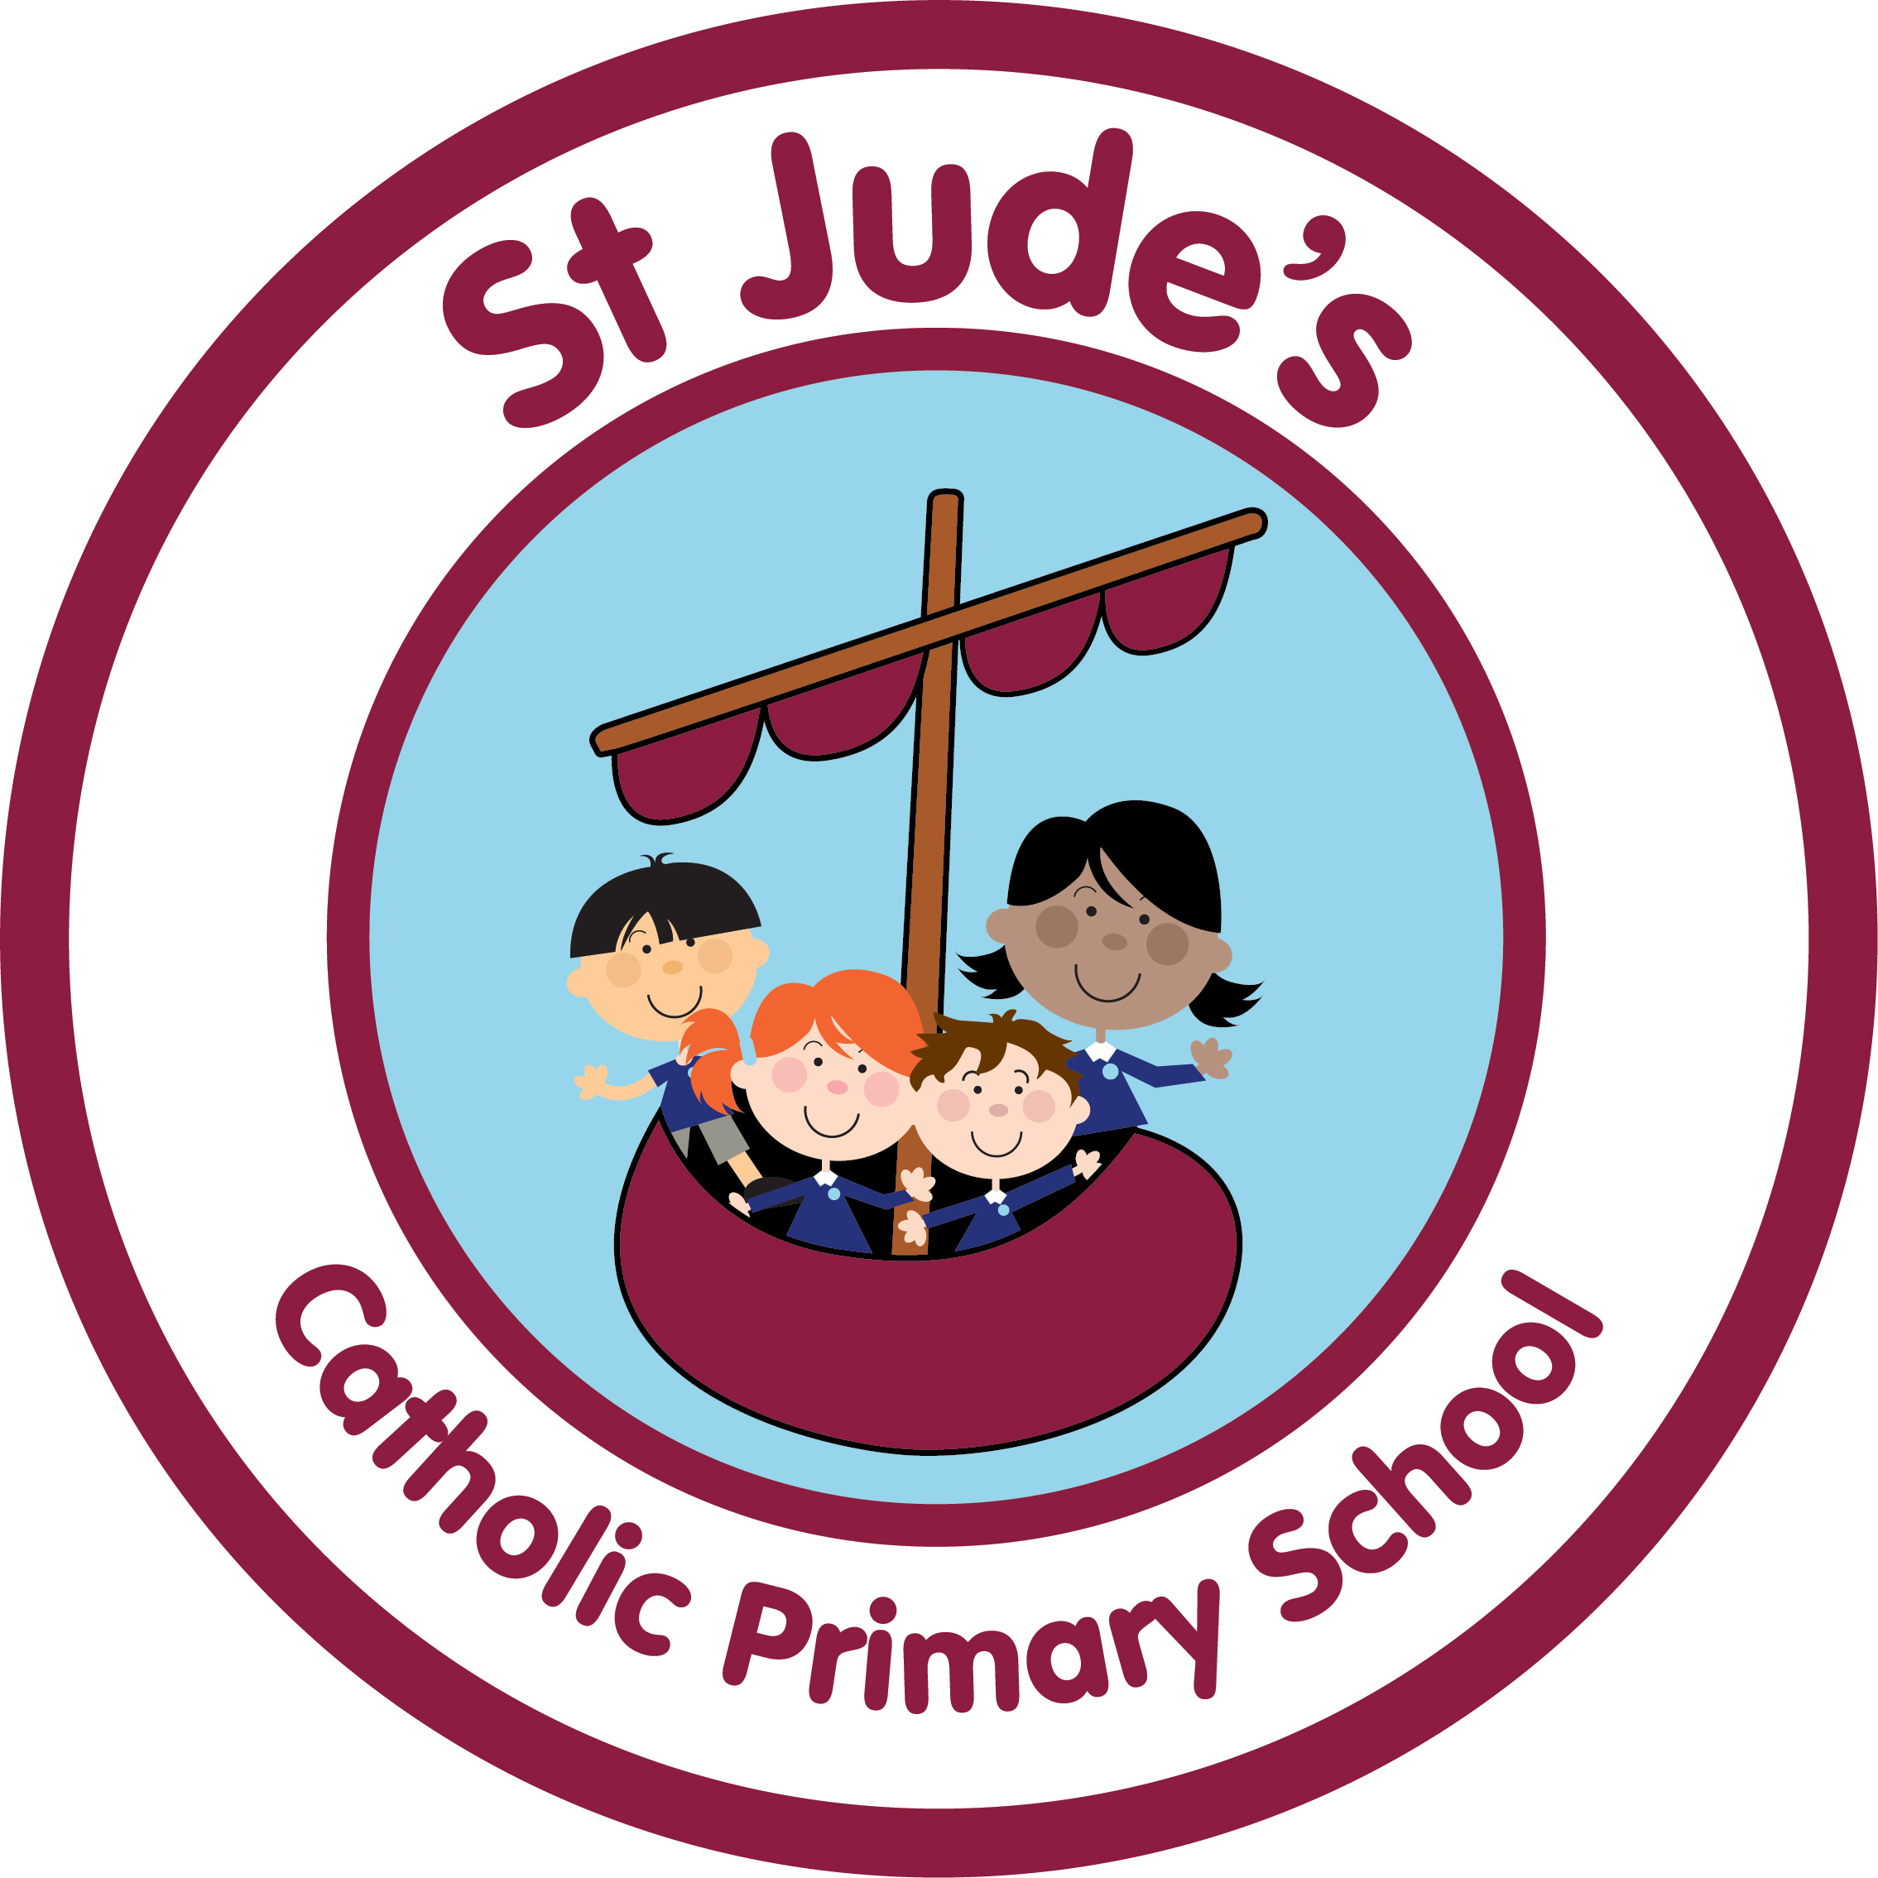

Collective Worship/
Prayer and Liturgy
Policy

Together, we learn, love and grow with Jesus
Written by: R. Jackson Autumn 2022
To be reviewed: Autumn 2024
“Worship is concerned with reverence or veneration paid to a divine being or power.”

(Circular 1/94)

At St. Jude’s School Collective Worship is provided daily, taking into account the religious and educational needs of all those who share it. While respecting the diversity of belief and commitment, it reflects the liturgical tradition of the Catholic Church.

Collective Worship is an important part of the Catholic Education offered at St. Jude’s school. It provides a time for prayer and worship which is separate from ordinary school activities. It may be related to day to day life, aspirations, concerns of the school and allows opportunities for each individual to make contributions towards it and to gain from it. Collective Worship is an educational experience or a reflection to which all can contribute and from which all can gain.
- Those who form part of the worshipping community in church,
- Those for whom school may be their first and only experience of church
- Those from other Christian traditions
- Those from other faith backgrounds.

Aims
Our aim in collective worship is to provide the school community with an opportunity to take part in worship in an active, conscious and genuine way. Through collective worship we aim to provide the opportunity for pupils and staff to come together daily to worship God to:

  - reflect on spiritual and moral issues
  - reflect on personal beliefs
  - develop community spirit
  - respond to and celebrate life
  - reinforce positive attitudes
  - contemplate something of the mystery of God
  - enable and encourage a sense of belonging
  - encourage a common ethos and shared values
  - build a firm foundation for liturgy
  - enrich the religious experience of children and staff
  - mark as special
  - give worth to
  - wonder at
  - take time out
  - come to terms with...

AN OVERVIEW OF COLLECTIVE WORSHIP

Who should be involved in Collective Worship?
- Pupils – they must have the opportunity to take part in daily Collective Worship
- Teachers - they plan and enable Collective Worship to take place each day
- All staff – they are invited to participate in all acts of Collective Worship
- Parents – they too are invited to participate in acts of Collective Worship during class assemblies,
- meetings for Sacramental preparation etc.

Where should Collective Worship take place?
An appropriate atmosphere will also be provided. It can be carried out at any point in the daytime and can take place in the following spaces:
- In the classroom
- In the hall
- In church
- In the open if appropriate
- School trips

When should Collective Worship take place?
Collective Worship need not occur at the beginning of the day but rather at the time that is
most appropriate for us as a school to ensure that it is a meaningful and prayerful
opportunity for all participants.

Resources
A box for collective worship resources is stored in each classroom, clearly labelled and items are changed on a daily basis according to the focus each day.
Extra resources are also stored in the whole school Collective Worship cupboard in the hall.

How should Collective Worship be delivered?
- Can be led by pupils, staff or visitors
- Can be offered for a class, a year group, a phase or whole school
- Should use a balance of quiet reflection, silence, prayers, responses, music, songs, dance, drama, slides, video or short address
- Should provide a focus using artefacts, candles, symbols and lighting
- Ensures the theme, focus, delivery, length and resources are appropriate to the interests, age range, backgrounds and abilities of the pupils
- Respect the freedom of the pupils and staff in the invitation to prayer and worship
- Set an appropriate atmosphere with a sense of order and occasion, including entry and exit
- Ensure the possibility of conscious, active participation of all present

HOW SHOULD COLLECTIVE WORSHIP BE PLANNED, RECORDED AND EVALUATED?

Planning
Themes for Collective Worship are determined with reference to the liturgical calendar,
significant dates and the Come and See curriculum, and with the flexibility to respond to
changing situations within the school and the wider Community. Key Stage Collective Worship is based on the Gospel Scripture from the Sunday mass. Spontaneous Collective Worship is also welcomed if appropriate, for example – natural disasters, family related (births/deaths).Each daily act of worship will be appropriate to the interest age range, background and ability of pupils.
Planning for Collective Worship is in four stages following a liturgical structure:

Gather
A space for the participants to gather is created. There will be a change in mood and a
powerful atmosphere created. Participants are invited to take part and this may involve
moving to another space with reverence and order. There may be a procession or a subtle
change in the seating and everyone is made to be welcome.
The atmosphere may be created using appropriate music, sensitive lighting or candles and a
focus display will set the scene for the theme or topic to be explored. The focus may contain,
drapes in appropriate colours, artefacts, the word of God, prayer cards, pictures, images,
candles etc. As everyone stills themselves for the worship, the leader will explain the focus
for the act of worship for all participants, drawing their thoughts to the quiet, reflective
opportunities ahead.

Listen
The participants are invited to listen to a carefully chosen piece of scripture. The word of God
is read /shared clearly so that everyone can hear and appreciate the words. The reading
may be shared using a power point presentation, pictures, role play, music etc. If a bible is
used, it should be treated with care and great respect so that all can see the importance of
this holy book.

Respond
The participants are supported to respond in a variety of ways. There may be time for
silent reflection, personal and private prayer, community prayer, singing. There may be a
response through action e.g. placing a pebble onto a display or sharing a sign of peace.

Go Forth
As the worship concludes, the leader may suggest ways that the message or theme may be
taken out and sustained, so that the participant my further spread the word and example of
God. There may be a challenge or a further question on which to reflect. A symbol, sign,
card or object may be given to each participant as they leave, to give further lasting meaning
to the collective worship.

Recording
The worship may be recorded through displays, prayers, photographs etc. Each class has a celebration folder for this purpose.

Evaluating
Staff and pupils regularly evaluate the worship and parents are asked to complete the visitors book after they have attended class worship.
Collective Worship is monitored by the RE coordinator each term. Samples of Collective Worship planning is monitored and collected by the RE coordinator each term.

OPPORTUNTIES PROVIDED FOR COLLECTIVE WORSHIP

Foundation stage staff do their own collective worship within their own settings, however, during the summer term, Nursery visit Foundation Stage for Collective Worship to help with transition and Reception visit KS1 on a Wednesday to help with their transition.

Key Stage One
Monday - Within class setting
Tuesday - Within class setting
Wednesday – in hall with KS1
Thursday - Within class setting
Friday - Within class setting

Key Stage Two
Monday - Within class setting
Tuesday - Within class setting
Wednesday - Within class setting
Thursday - in hall with KS1
Friday - Within class setting

Parents have the right to withdraw their child from daily collective worship.

Class Collective Worship
There will be a series of whole class collective worships throughout the year to which parents will be invited.

Whole School
Throughout the year pupils participate in mass, and deliver seasonal services for parents and members of the community
Eg. Harvest Thanksgiving, Advent, Carol service, Ash Wednesday, Easter service, Corpus Christi, St. Peter and Paul etc.

Leavers
A special Mass is celebrated at the end of the academic year, which recalls the children’s journey through our school and points them towards their future lives in Secondary School.

Sacramental Preparation
We believe that it is essential that Home, School and Parish work very closely together in preparing each pupil for the Sacraments.

St. Jude’s Catholic Primary School fully supports the parish in their preparation of the
children for the Sacraments of Eucharist and Reconciliation. Parents are invited to an initial
meeting during which the process of preparation and the commitment required is outlined.
Input from the parish priest, school and catechists is given.
We follow the ‘With You Always’ Programme. This is a resource for parents and their
children who are in Year 4. The resource encourages parents/carers and children to meet
together with parish catechists, supported by the school, to learn about the sacraments using
the family catechesis method. Parents are the first and best teachers of their children in the
ways of faith as is made clear when the child is baptised. The goal of family catechesis is
the evangelisation of the whole family with particular emphasis on the support of parents to
pass on the faith to their children. Family catechesis helps support the Home-Parish-School
partnership.

Prayer
At the beginning and end of each day, and before and after lunchtime, prayers are said within the classroom. Prayers are also shared during our Achievers Assembly to thank God for our talents. Our local priest also visits KS2 classes to say the Rosary on a weekly basis.

The children are given the opportunity to attend Mass in school and at Church
- Harvest Mass – October
- All Saints and All Souls Day - November
- Christmas Mass – December
- Easter Mass – Spring
- Feast of St. Peter and St. Paul - June
- Leavers Mass – July

Conclusion:
In order to encourage Collective Worship we will provide the necessary resources, materials and settings. Pupils will be given opportunities for involvement to enable them to demonstrate their growing knowledge and appreciation of the religious dimension in their lives. Pupils will be encouraged to plan and lead Collective Worship where appropriate.

Review
The Collective Worship Policy will be subject to regular monitoring by members of the teaching staff led by the Religious Education Coordinator and will be reviewed on an annual basis by the Headteacher and Governors.

